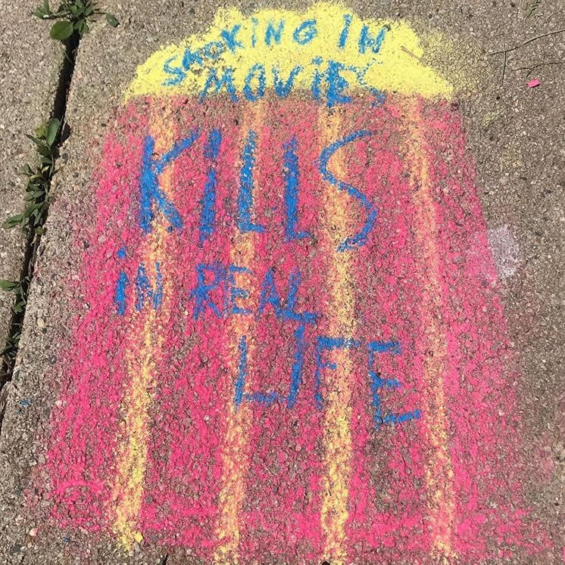
SMOKE-FREE MOVIES
Chalk the Walk - Tool-kit
SMOKE FREE MOVIE CHALK THE WALK TOOL-KIT
COORDINATOR GUIDE
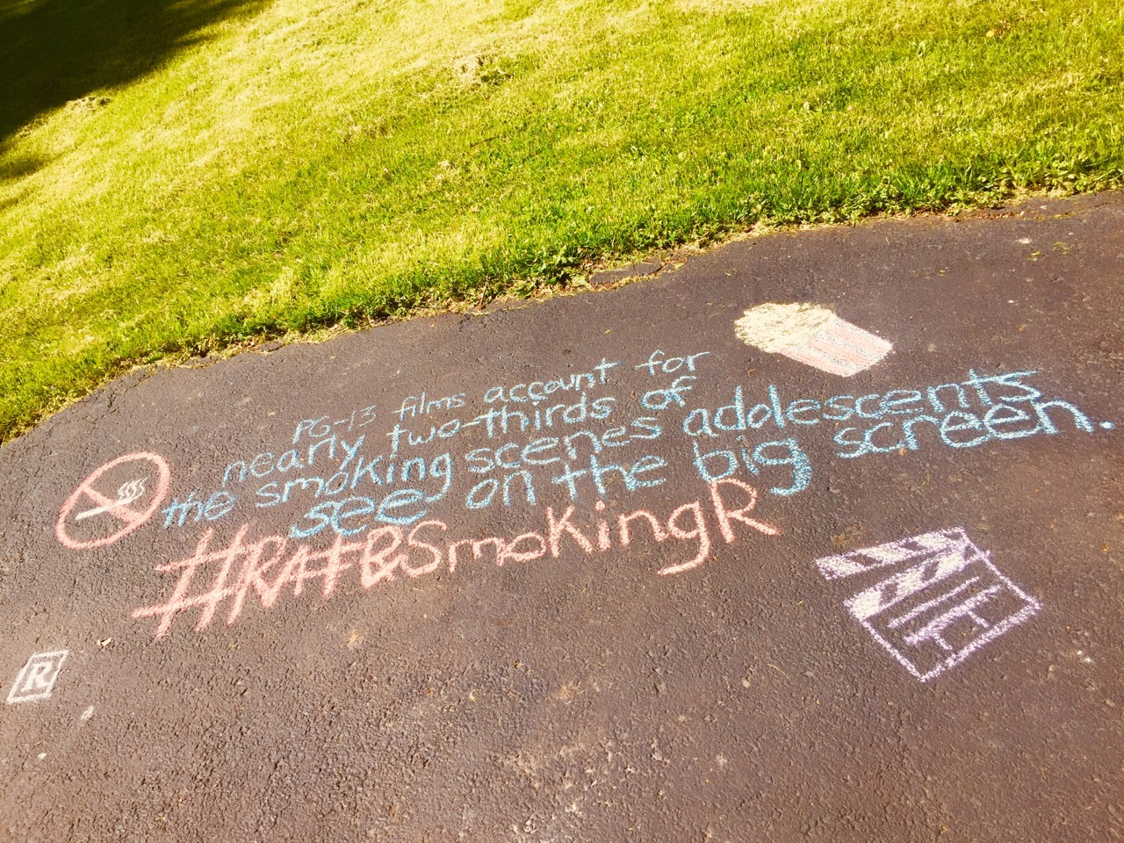
When you can’t get together to take action, let the action happen from home. This is a toolkit that can help share our message, spread positivity and raise awareness; while allowing a little healthy connection.

YOU WILL NEED
- Sidewalk Chalk
- Smoke Free Movies Facts Sheet
- Flat outside place to write with chalk (get permission first)
- Cell Phone to take photos
INSTRUCTIONS
- Set up your outside blacktop area (with permission granted first) and be sure it is clean and dry.
- Start using your Smoke Free Movies facts sheet and write with the chalk a statistic on the ground. Include an appropriate drawing with the wording.
- Include hashtag #SeenEnoughTobacco or #RateSmokineR
- Take a photo and post to social media using your hashtag #.

WORKPLAN DELIVERABLES CHECK LIST
EQUIP (youth infrastructure)
- Provide youth leaders with an overview of the activity, discuss timelines, materials needed, possible barriers and how they might overcome them.
- Provide youth leaders with the materials that they will need, or discuss with them how they will obtain them.
- Provide youth leaders with a plan to report back their findings
- Discuss with the youth leaders ways in which this activity will educate their community and their elected officials.
- Discuss with the youth leaders what organizational decision makers this activity may impact and discuss ways in which youth can advocate this project with those decision makers. Create a plan with the youth.
- Discuss with the youth leaders who else can help with this project? Who can we “mobilize?’ Create a plan with the youth to make those connections and a plan to follow through.
- Discuss with the youth leaders how you can let others know about what you are doing? Is there a news outlet they want to reach out to? How will you share the activity on Social Media? What media can be tagged? Create a plan with the youth to make those connections and make the posts.
- Discuss with the youth “how will we know that this activity was successful?” How will you evaluate the activity?
- Once the activity is complete take time with your youth to discuss the following 1) What went well? 2) What didn’t 3) What could we improve? 4) Will we want to do this again? 5) Who else can we share with about what we did?
- Work with your youth to create a short presentation or summary with photos and outcomes. This can be shared in an online newsletter, shared with other RC groups, and shared on our website realitycheckofny.com and our statewide social media sites.
EDUCATE
- Who will be educated as a result of this activity?
- How will you reach them?
- How many people will be educated?
- How will you know you were successful?
- What community members were educated, how many, and what was done to educate them?
- Did you communicate directly with the community members? How?
- What government policy makers were educated, how many, and what was done to educate them?
- Did you communicate directly with a government policy maker? How?
ADVOCATE
- What organizational decision makers will you advocate for change with as a result of this activity?
- What action do you want the organizational decision maker to take?
- How will you engage them?
- How will you know you were successful?
PROMOTE
How will you let the media and the community know about what you are doing?
Who will you contact and how will you contact them?
How will you know you were successful?
Don’t forget to share any media coverage with your elected officials!

MOBILIZE
- Who will you mobilize for this activity?
- How many people/organizations will be mobilized?
- What action do you want them to take?
- How will you engage them to take action
- How will you know that they took action?
- How will you know you were successful?

LINKS TO MATERIALS

Sidewalk Chalk-$24.95 for 120 pieces
ref=sr_1_10

SFM FACTS & STATISTICS

- The average age of a new smoker in NYS is 13
- Tobacco use is the number one cause of preventable death in the U.S.
- 90% of smokers start before the age of 18.
- The more young people see tobacco, the more likely they are to start smoking.
- Giving an R rating to future movies with smoking would be expected to reduce the number of teen smokers by nearly 1 in 5 and preventing up to 1 million deaths from smoking among children alive today.
- The latest study found 92% of streaming shows most popular with teens depicted smoking
- 6 of every 10 PG-13 movies (58%) showed smoking or other tobacco use.
- In-theater tobacco impressions more than doubled over the past five years, from 9.3 billion in 2015 to 23.7 billion in 2019.
- In 2019, U.S. Senators asked Hollywood two basic child-safety questions: How many of their films and TV shows include tobacco? How many kids see it? Hollywood ignored the questions. They simply did not answer.
- One little letter "R" will save one million lives.
- Reality Check wants to create a generation that is free from tobacco and second-hand smoke and the death and disease that they cause.

