Advocating with organizational Decision makers
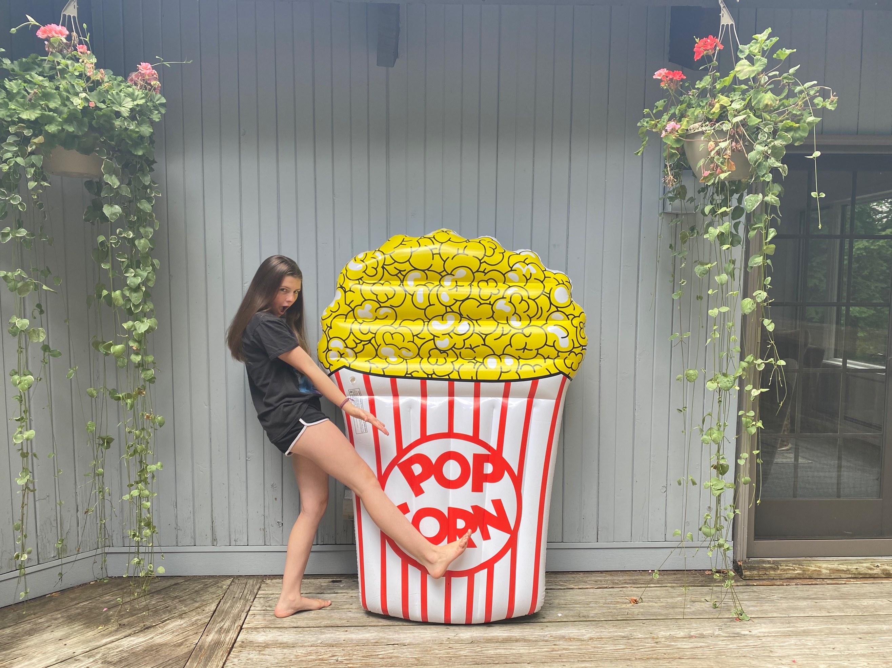
SMOKE-FREE MOVIES
Home Action - Tool-kit

COORDINATOR GUIDE
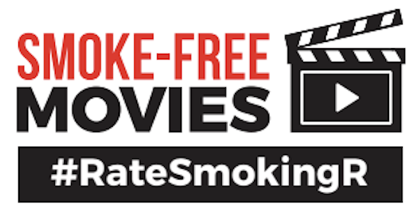
When you can’t get together to take action, let the action happen from home. This is a toolkit that can help you speak truth to power, while allowing a little healthy competition.

You Will Need
- A box or large envelope to mail the items
- Envelopes, stamps, address labels
- Fun items to include in the package (popcorn, lemonade drink mix, fruit snacks, movie themed items and props.)
- Sidewalk chalk
- Smoke-Free Movies Facts
- Sample Letter (one they can just add their own message or just sign and send)
- Scavenger Hunt Worksheet
- BINGO CARD of activities (tracks points too)
- An envelope to have them mail back the Scavenger Hunt & BINGO worksheet
- Youth should have a cellphone to take photos
INSTRUCTIONS

- Order items that you want to include in the kit
- Print out the items for the kit
- Send them out to your youth
- Allow no more than 2 weeks to complete
- Look for photos on social media from your youth with the hashtag #RateSmokingR or whatever hashtag you decided to use.

WORKPLAN DELIVERABLES CHECK LIST
EQUIP (youth infrastructure)
- Provide youth leaders with an overview of the activity, discuss timelines, materials needed, possible barriers and how they might overcome them.
- Provide youth leaders with the materials that they will need, or discuss with them how they will obtain them.
- Provide youth leaders with a plan to report back their findings
- Discuss with the youth leaders ways in which this activity will educate their community and their elected officials.
- Discuss with the youth leaders what organizational decision makers this activity may impact and discuss ways in which youth can advocate this project with those decision makers. Create a plan with the youth.
- Discuss with the youth leaders who else can help with this project? Who can we “mobilize?’ Create a plan with the youth to make those connections and a plan to follow through.
- Discuss with the youth leaders how you can let others know about what you are doing? Is there a news outlet they want to reach out to? How will you share the activity on Social Media? What media can be tagged? Create a plan with the youth to make those connections and make the posts.
- Discuss with the youth “how will we know that this activity was successful?” How will you evaluate the activity?
- Once the activity is complete take time with your youth to discuss the following 1) What went well? 2) What didn’t 3) What could we improve? 4) Will we want to do this again? 5) Who else can we share with about what we did?
- Work with your youth to create a short presentation or summary with photos and outcomes. This can be shared in an online newsletter, shared with other RC groups, and shared on our website realitycheckofny.com and our statewide social media sites.
EDUCATE
- Who will be educated as a result of this activity?
- How will you reach them?
- How many people will be educated?
- How will you know you were successful?
- What community members were educated, how many, and what was done to educate them?
- Did you communicate directly with the community members? How?
- What government policy makers were educated, how many, and what was done to educate them?
- Did you communicate directly with a government policy maker? How?
ADVOCATE
- What organizational decision makers will you advocate for change with as a result of this activity?
- What action do you want the organizational decision maker to take?
- How will you engage them?
- How will you know you were successful?
PROMOTE
- How will you let the media and the community know about what you are doing?
- Who will you contact and how will you contact them?
- How will you know you were successful?
- Don’t forget to share any media coverage with your elected officials!

MOBILIZE
- Who will you mobilize for this activity?
- How many people/organizations will be mobilized?
- What action do you want them to take?
- How will you engage them to take action
- How will you know that they took action?
- How will you know you were successful?

Advocating with organizational Decision makers
When we can’t get together to take action, let the action happen from home. This is a toolkit that can help you speak truth to power, while allowing a little healthy competition.

You Will Need
- Envelopes, stamps, address labels
- Fun items like popcorn, lemonade drink mix, fruit snacks, movie themed items and props.
- Sidewalk chalk
- Smoke-Free Movies Facts
- Sample Letter (just add your own message or just sign & send)
- Scavenger Hunt Worksheet
- BINGO CARD of activities (tracks points too)
- An envelope to mail back the Scavenger Hunt & BINGO worksheet
- A cellphone to take photos
INSTRUCTIONS
- Complete as many as the items from the BINGO CARD as you wish!
- Complete the Scavenger Hunt Worksheet
- Send the letters out in the mail – take photos!
- Report back to your coordinator or advisor in less than two-weeks to let them know what you did – either mail it back or take a photo and send it!
- Look for photos posted on social media from others across the state with the hashtag #RateSmokingR

SFM Writing prompts

FACTS & LINKS
Letter Writing/Emails
What is your favorite show or movie?
What company "owns" that show or movie?
Send that company a letter and email too telling them how you feel about smoking, vaping, or tobacco use in that show or movie and what you want them to do about it?
After you tell them what show/movie you like that is one of theirs then add in something like this.... or use one of these lines in any of your social media posts.

- “Rate Smoking R! Keep smoking and tobacco imagery out of shows and movies that kids like me watch.”
- “Give smoking in movies the R rating that it deserves! Kids shouldn't be exposed to smoking, the number one cause of death and disease in this country.”
- “Isn't it time to do the right thing, you can help prevent the influence on kids to use tobacco. Please do your part.”
And then do the same for the other companies - you don't have to tell them about your favorite show or movie, you can just keep it short and sweet.

Links to the sources to support what you are saying
University of California SanFrancisco http://smokefreemovies.ucsf.edu
Surgeon General's Report SG Report: The Health Consequence of Smoking 50 years of progress
See Chapter 14 (pages 775 -777)
CDC Fact Sheet CDC Fact Sheet: Smoking in Movies
World Health Organization Smoke-Free Movies: From Evidence to Action

ELEMENTS OF A LETTER
- Introducing oneself: Who you are, where you are from, what groups you are connected with.
- Making a demand: Be specific with the issue you are concerned about; state your desired outcome.
- Encourage accountability: Ask them to make their stance public; create a new policy
- Keeping it brief: Letters should be to the point and under a page long.

Let’s practice your writing skills!
- In the toolkit, you will find stamped and labeled envelopes, postcards of support and sample letter (pg. 5).
- Write a letter to the Motion Picture Association and/or Parent Companies of Major Movie Studios
  - Use the facts and statistics
  - Use the sample letter for guidance and this website is also a great resource: https://smokefreemovies.ucsf.edu/
- Write a letter to the Editor.
  - Write a short letter about what you are doing in Reality Check and we want to Rate Smoking R.
  - Letter should be no more than 400 words.
  - Contact your coordinator for help or review.

EXAMPLE

Dear CEO of Motion Picture Association,

My name is XYZ and I live in XYZ, NY. I belong to a group called Reality Check and one of our initiatives is building awareness for the importance of smoke-free movies.
Smoking in movies rated G, PG, and PG-13 has a major influence on children and teenagers. It impacts their decision making and judgment when they see their favorite actor, actress or character smoke or vape on screen. Tobacco use in the leading preventable cause of death in the United States. According to the US Surgeon General, exposure to onscreen smoking in movies causes young people to start smoking.
You already tailor movies to meet certain age requirements, it is also important to rate them according to their smoking content - rating new smoking movies “R.” Any future film that shows or implies tobacco should be given an adult rating, which in the U.S. is an R-rating.
Help make youth rated movies tobacco and vape free and rate smoking R!

Sincerely,
Name, School, Grade

Keep smoking out of what kids watch . . . and save one million lives.
- Go to https://www.change.org/p/smoking-on-screen-kills-in-real-life-save-a-generation-ratesmokingr to sign the online petition
- Help us get to 50,000 signatures!

MORE FACTS & STATISTICS

- The average age of a new smoker in NYS is 13
- Tobacco use is the number one cause of preventable death in the U.S.
- 90% of smokers start before the age of 18.
- The more young people see tobacco, the more likely they are to start smoking.
- Giving an R rating to future movies with smoking would be expected to reduce the number of teen smokers by nearly 1 in 5 and preventing up to 1 million deaths from smoking among children alive today.
- The latest study found 92% of streaming shows most popular with teens depicted smoking
- 6 of every 10 PG-13 movies (58%) showed smoking or other tobacco use.
- In-theater tobacco impressions more than doubled over the past five years, from 9.3 billion in 2015 to 23.7 billion in 2019.
- In 2019, U.S. Senators asked Hollywood two basic child-safety questions: How many of their films and TV shows include tobacco? How many kids see it? Hollywood ignored the questions. They simply did not answer.
- One little letter "R" will save one million lives.
- Reality Check wants to create a generation that is free from tobacco and second-hand smoke and the death and disease that they cause.
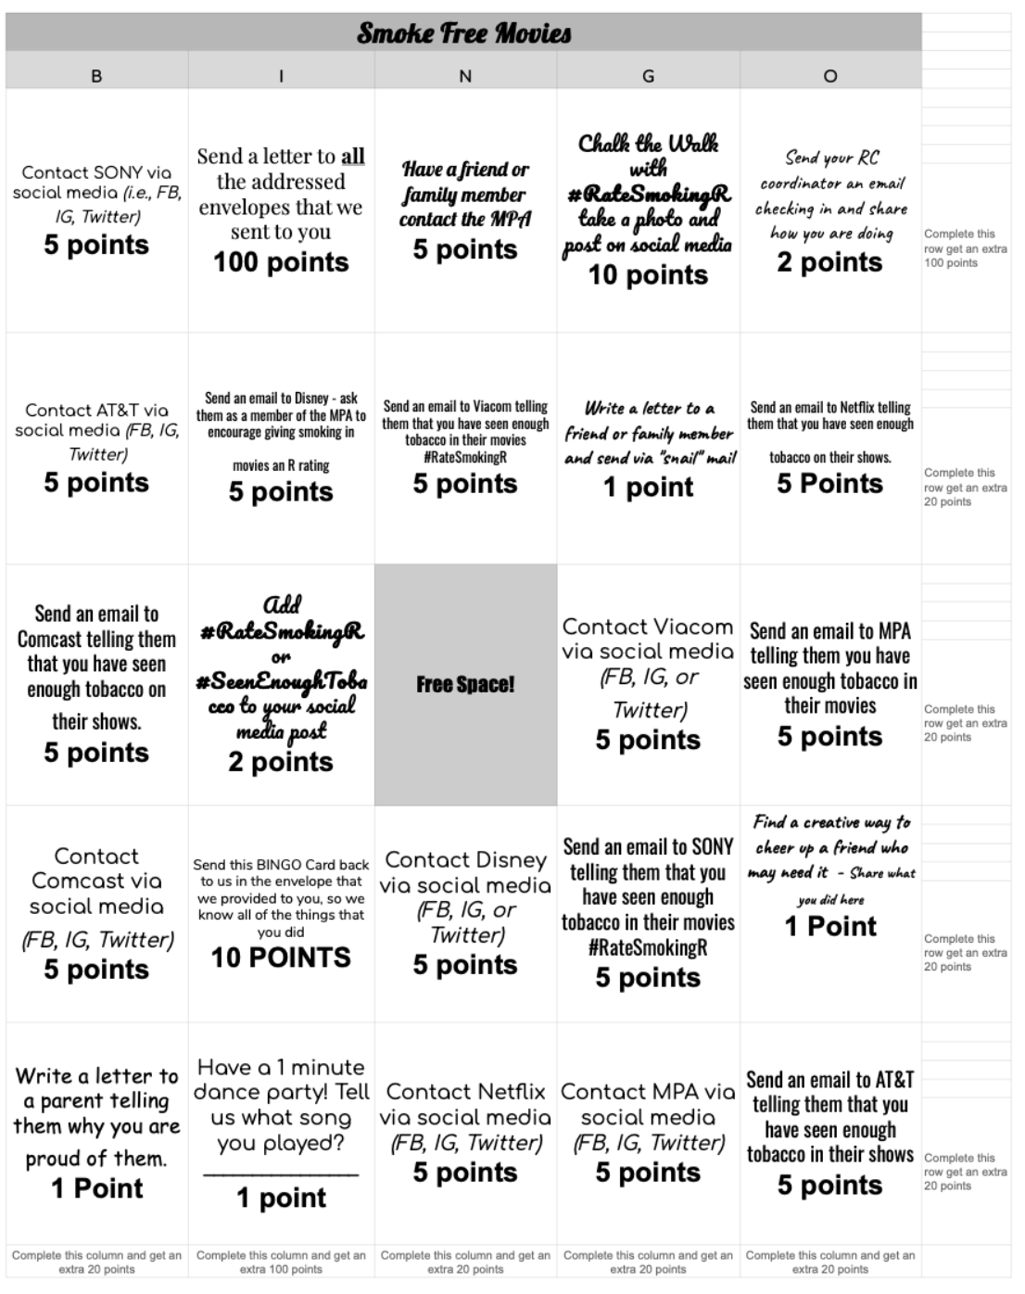
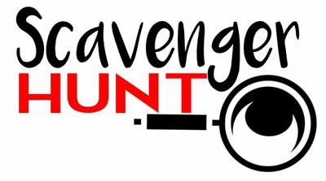
Go to http://www.realitycheckofny.com/. Find the answers to the questions and then complete the tasks. Have fun with it! (Please include this in the envelope with your BINGO card)

Films with a ________ rating account for nearly two-thirds of the smoking scenes adolescents see on the big screen. (answer, PG-13)

Smoking in movies recruits ________________ new teen smokers every year. (answer, 187,000)

When was the Smoke Free Media Guide developed? (answer, B)
- 2009 b. 2012 c. 2013 d. 2018

What show included tobacco in 100% of its episodes? (answer, A)
- Stranger Things
- The Office
- Bates Motel
- Degrassi: The Next Generation

Please choose one of the following to complete. Once you are done, make sure to send your drawing to your coordinator! (You may be featured on the Reality Check Instagram page)

Draw a picture of what you would like as a Superhero

OR

Draw what you think the Reality Check mascot would look like

FACT:

FACT:

FACT:

