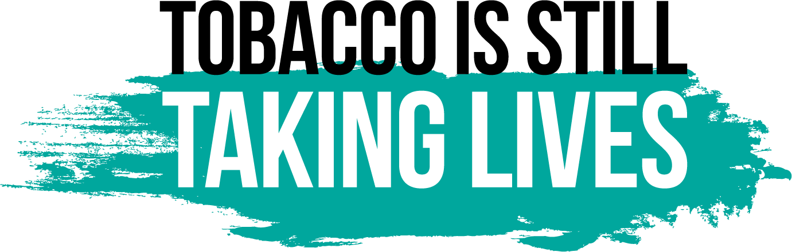 BOOKLET RESOURCES
Tobacco Marketing in the Retail Environment
86% of African American smokers’ smoke menthol cigarettes compared to 36% of white smokers.
Tobacco Use Among African Americans.” Campaign for Tobacco-Free Kids. 2021. https://www.tobaccofreekids.org/assets/factsheets/0006.pdf
Delnevo, CD, et al., “Banning Menthol Cigarettes: A Social Justice Issue Long Overdue,” Nicotine & Tobacco Research, 22(10): 1673-1675, 2020.
More than 80% of youth who use tobacco products started with a flavored product and continue to use flavored tobacco products.
“Flavored Tobacco Products Attract Kids: Brief Overview of Key Issues.” Campaign for Tobacco-Free Kids, 2022. https://www.tobaccofreekids.org/assets/factsheets/0399.pdf.
In New York State, 1 in 4 high school students currently uses a tobacco product.
https://www.health.ny.gov/prevention/tobacco_control/reports/statshots/volume14/n3_milestones_in_tobacco_control.pdf
Cigars, little cigars, and smokeless tobacco are available in a wide variety of sweet, fruit and candy flavors and can cost as little as 5 for a $1; New York State high school students use these flavored tobacco products at 2.5x the rate they use cigarettes.
https://www.health.ny.gov/prevention/tobacco_control/reports/statshots/volume14/n3_milestones_in_tobacco_control.pdf
Smoke-Free Movies
The U.S. Surgeon General concluded that on-screen smoking influences youth smoking.
U.S. Department of Health and Human Services. Preventing Tobacco Use Among Youth and Young Adults: A Report of the Surgeon General.
Research shows that the more smoking young people see on screen, the more likely they are to start smoking.
U.S. Department of Health and Human Services. Preventing Tobacco Use Among Youth and Young Adults: A Report of the Surgeon General.
Tobacco imagery on screen is often unrealistic and both normalizes and glamorizes tobacco use.
Heatherton TF, Sargent JD. Does Watching Smoking in Movies Promote Teenage Smoking? Curr Dir Psychol Sci. 2009 Apr 15; 18(2):63- 67
Giving an R-rating to movies with smoking would avert 1 Million of those smoking deaths among today’s children and teens.
https://truthinitiative.org/press/press-release/leading-health-groups-demand-film-industry-give-r-rating-movies-depict-smoking
Smoke-Free Housing
More than 1 in 3 nonsmokers who live in rental housing are exposed to secondhand smoke.
https://www.cdc.gov/vitalsigns/tobacco/index.html
The home is the primary source of secondhand smoke exposure for children and a major source for nonsmoking adults.
https://www.cdc.gov/tobacco/secondhand-smoke/going-smokefree-matters/multi-unit/index.html
Secondhand smoke exposure is twice as high for people living below the poverty level compared with those living above the poverty level.
https://www.cdc.gov/tobacco/health-equity/low-ses/secondhand-smoke.html
There is no safe level of exposure to secondhand smoke.
https://www.cdc.gov/tobacco/secondhand-smoke/going-smokefree-matters/multi-unit/index.html
Exposure to secondhand smoke can cause Sudden Infant Death Syndrome (SIDS), asthma attacks, heart disease and cancer.
https://www.cdc.gov/tobacco/secondhand-smoke/going-smokefree-matters/multi-unit/index.html
Health Systems for a Tobacco-Free New York
Smoking is still the leading cause of preventable death and disease in New York State. https://www.cdc.gov/tobacco/stateandcommunity/state-fact-sheets/new-york/index.html
There are seven FDA-approved methods to treat nicotine addiction, and e-cigarette use is not one of them.
U.S. Food and Drug Administration. FDA 101: Smoking Cessation Products.
https://www.fda.gov/consumers/consumer-updates/fact-or-fiction-what-know-about-smoking-cessation-and-medications
While 25% of adults in the U.S. have a behavioral health condition, they consume almost 40% of all cigarettes smoked by adults in this country.
Substance Abuse and Mental Health Services Administration. (2012). Results from the 2011 National Survey on Drug Use and Health: Mental health findings (NSDUH Series H-45, HHS Publication No. SMA 12-4725). https://www.samhsa.gov/data/sites/default/files/spot104-cigarettes-mental-illness-substance-use-disorder/spot104-cigarettes-mental-illness-substance-use-disorder.pdf
A health care provider’s advice and assistance more than doubles the odds that a patient will successfully quit smoking.
https://www.cdc.gov/tobacco/sgr/2020-smoking-cessation/fact-sheets/pdfs/healthcare-professionals-health-systems-h.pdf

Tobacco-Free Outdoors
Even brief exposure to secondhand smoke may increase the severity of asthma attacks and lower respiratory tract infections and has adverse effects on the heart.
https://www.cdc.gov/tobacco/secondhand-smoke/health.html
Discarded cigarette butts pollute the land and water and are highly toxic and dangerous to children, pets, and wildlife
https://truthinitiative.org/research-resources/harmful-effects-tobacco/5-ways-cigarette-litter-impacts-environment
Tobacco use in family-friendly places such as playgrounds, parks, and athletic events models unhealthy behavior and normalizes the use of tobacco.
https://www.ncbi.nlm.nih.gov/books/NBK236769/
Tobacco-free outdoor policies increase the number of tobacco users who are motivated to quit and supports the efforts of tobacco users who attempt to quit.
https://www.cdc.gov/tobacco/secondhand-smoke/protection/reduce-smoking.htm

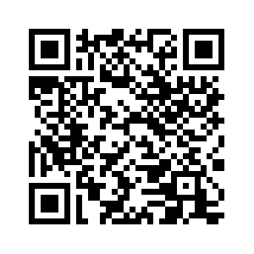
Scan QR Code for https://tobaccofreenys.org/events/legislative-education-day/
More Information
and Resources

