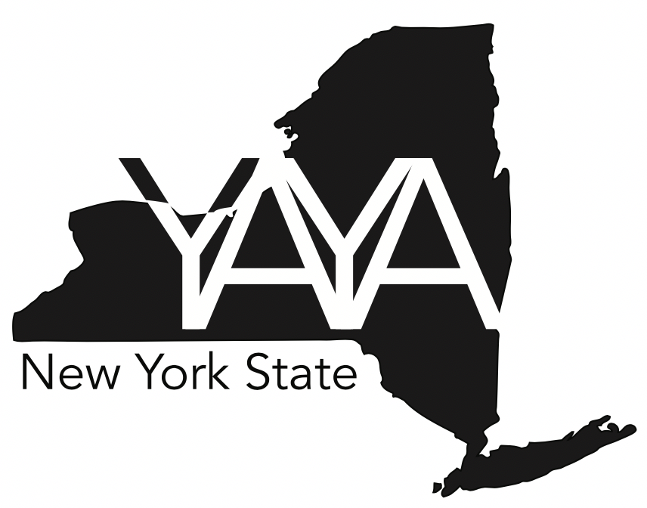
2026 Youth Ambassador of the Year Awards
Presented by Reality Check of New York State
The Youth Ambassador of the Year Awards celebrate young leaders across New York State who are taking bold action to expose and challenge the tobacco industry’s influence on youth. These outstanding Reality Check members are protecting their peers and strengthening their communities through public education, creative advocacy, peer mentorship, and outreach to policymakers.
Across the state, Reality Check youth are working to reduce tobacco industry access to young people, limit exposure to harmful marketing and imagery, and build healthier environments where all youth can live, learn, work, and play. Their passion inspires the next generation of changemakers—and this award honors that impact.
Awards Overview
Reality Check of New York State will recognize:
- One Statewide Youth Ambassador of the Year & Three Additional Regional Youth
  - Western NY
  - Central NY
  - Capital Region
  - MARO Region
State and Regional winners will be honored at statewide and local events, celebrated by local elected officials and program leaders, and offered opportunities to take on meaningful roles within Reality Check throughout the year. These may include:
- Serving as a spokesperson or youth representative
- Helping to guide local, regional, or statewide initiatives
- Participating in conferences, leadership programs, and special events
This is a challenge-by-choice role. Participate at any level that fits interest and schedules.
Application Deadline
Applications are due online by midnight on Sunday April 26, 2026
Submit at: www.RealityCheckofNY.com
Applicants must use a Google account to submit. But, we do recommend completing it first “on paper” then using that to enter in the google form.
Judging Criteria & Process
A panel of judges will review all submissions using a shared statewide rubric.
Finalists and winners will be announced in June 2026.
Why Apply?
Your work matters—and deserves to be recognized.
Reality Check thrives because of youth who speak out, show up, and create real change in their communities. The Youth Ambassador of the Year Awards shine a spotlight on the leaders who are:
- Protecting their peers from tobacco industry tactics
- Educating their schools and communities
- Inspiring others to step into advocacy
- Working toward a healthier, tobacco-free New York State
YAYA winners receive:
🟦 Recognition
- A statewide celebration event at the RC State Summit - Summer 2026
- Local recognition from legislators, community partners, and Reality Check leaders
- Official awards and certificates
🟦 Leadership Opportunities
- Serve as a voice for youth in statewide tobacco control efforts
- Join youth boards, special projects, or ambassador roles
- Represent Reality Check at local, regional, and national events
🟦 Future-Ready Experience
- A major resume and college-application booster
- Opportunities to build public speaking, leadership, and advocacy skills
Application Checklist
✓ Four written statements
✓ 1–3 minute video
✓ Coordinator reference (250 words or fewer)
✓ Current digital headshot
✓ Completed online application form
WRITTEN STATEMENTS (up to 750 words each) - 40 Points
Tell us your story!
Each statement should describe your experience in the following areas, with examples that show growth, passion, creativity, and impact.
1. Advocacy (10 Points)
- How have you spoken up for Reality Check or tobacco-free communities?
- Describe work with legislators, media, community leaders, or events.
- What have you learned from both successes and challenges?
2. Initiative & Impact (10 Points)
- What ideas have you contributed or led?
- Describe a project, event, or activity you helped bring to life.
- What tobacco-related issues have you noticed locally—and what did you do about them?
- Share a moment where your efforts changed someone’s perspective.
3. Leadership (10 Points)
- How have you encouraged or mobilized other youth?
- What leadership qualities do you bring to Reality Check?
- How have you helped move your community toward change?
4. Creative Thinking & Problem Solving (10 Points)
- How have you used your creativity to amplify Reality Check’s message?
- Share ways you’ve solved problems or overcome obstacles in tobacco control work.

VIDEO STATEMENT (1–3 minutes) - 10 Points
Use your video to show us who you truly are, your voice, your passion, and your Reality Check story.
Your video should include:
- Your name, county, school district
- Who you are outside of Reality Check
- Why you joined and why the work matters to you
- What you hope to do as a Youth Ambassador
- Footage or photos of your Reality Check activities
Tips
- Be creative—music, interviews, visuals, and storytelling are welcome.
- Ask coordinators, teachers, or family to help you or appear in the video.
- Ensure clear audio and a clean background.
- Videos under 1 minute or over 3 minutes cannot be scored.
COORDINATOR REFERENCE - 5 Points
Each applicant must include a short statement (250 words or fewer) from their Reality Check coordinator describing why they believe the youth should be selected.
References may be emailed to: tobaccofree@cvfamilycenter.org
OVERALL APPLICATION QUALITY - 5 Points
How clearly and carefully is the application written and presented?
What to consider:
- Grammar and spelling
- Clear, complete responses
- Organization and readability
- Overall care and effort in completing the application

Scoring Guide (1–5 scale)
5 – Excellent
Application is very clear, well-organized, and carefully completed. Minimal or no grammar or spelling errors.
4 – Strong
Application is clear and organized with only minor errors that do not affect understanding.
3 – Adequate
Application is understandable but has noticeable grammar, spelling, or organization issues.
2 – Needs Improvement
Multiple errors or unclear sections that make the application difficult to read or follow.
1 – Limited
Significant errors or lack of completion that make the application hard to understand.

